
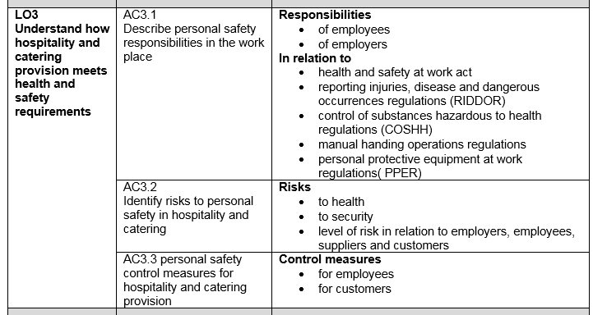
Name

Group

LEVEL 1 / 2 AWARD IN
HOSPITALITY AND CATERING unit 1
AO3
Understand how hospitality and catering provision meets health and safety requirements

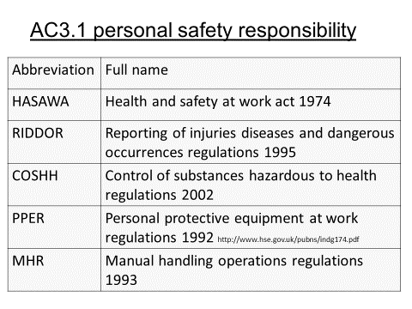
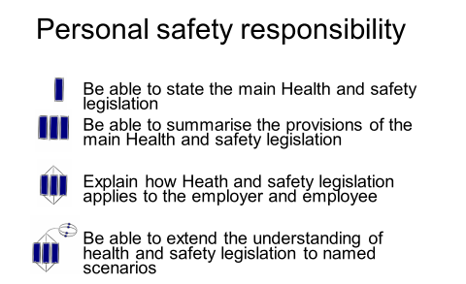
Duties of employers under the HASAWA
………………………………………………………………………………………………………………………………………………………………………………………………………………………………………………………………………………………………………………………………………………………………………………………………………………………………………………………………………………………………………………………………………………………………………………………………………………………………………………………………………………………………………………………………………………………………………………………………………………………………………………………………………………………………………………………………………………………………………………………………………………………………………………………………………………………………

Duties of employees under the HASAWA
………………………………………………………………………………………………………………………………………………………………………………………………………………………………………………………………………………………………………………………………………………………………………………………………………………………………………………………………………………………………………………………………………………………………

What does HSE stand for and what is the role of the organisation ?
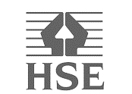

Accidents at work
All accidents however minor should be reported to a supervisor
What else should you report to them?
.

.

.

Substances covered by COSHH
Duties of employees under the COSHH
………………………………………………………………………………………………………………………………………………………………………………………………………………………………………………………………………………………………………………………………………………………………………………………………………………………………………………………………………………………………………………………………………………………………………………………………………………………………………………………………………………………………………………………

Common substances and controls

- Cleaning chemicals
- Washing up liquid
- Cooking fumes
- Smoke
- Oils
- Gas
- Wear gloves
- Extractors over cookers
- Face mask

Label the symbols
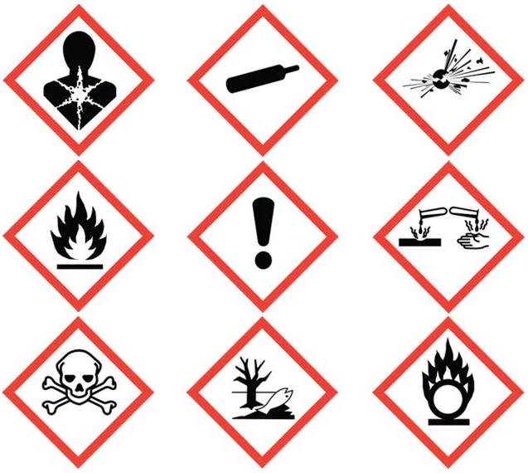

RIDDOR
Reporting of injuries, Diseases and Dangerous Occurrences Regulations

What has to be reported to HSE under the RIDDOR
………………………………………………………………………………………………………………………………………………………………………………………………………………………………………………………………………………………………………………………………………………………………………………………………………………………………………………………………………………………………………………………………………………………………………………………………………………………………………………………………………………………………………………………

Occupational diseases that must be reported
………………………………………………………………………………………………………………………………………………………………………………………………………………………………………………………………………………………………………………………………………………………………………….……………………………………………………………………………………………………………………………………………………………………………………………………………………………………………………………………………………..

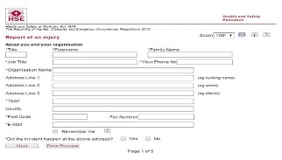
Reporting to HSE



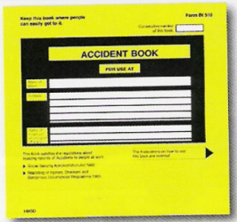

Other accidents to go in the

Personal protective equipment
What PPE would front of house staff need for the following?
Employees must
………………………………………………………………………………………………………………………………………………………………………………………………………………………………………………………………………………………………………………………………………………………………………………………………………………………………………………………………………………………………………………………………………………………………………………………………………………….….
Employers must
………………………………………………………………………………………………………………………………………………………………………………………………………………………………………………………………………………………………………………………………………………………………………………………………………………………………………………………………………………………………………………………………………………………………………………………………………………….….
What items of PPE are used un a catering situations?
………………………………………………………………………………………………………………………………………………………………………………………………………………………………………………………………………………………………………………………………………………………………………………………………………………………………………………………………………………………………………………………………………………………………………………………………………………….….
What does PPE mean ?

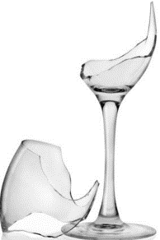
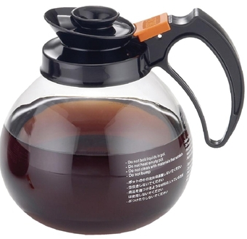

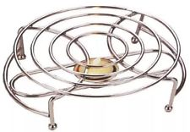

MHR
Manual handling regulations

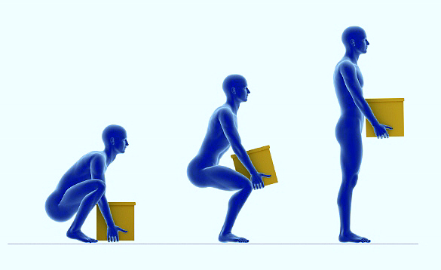
- Avoid manual handling which may be a risk to health as far as reasonably practicable
- Carry out a risk assessment before handling
- Instruction in handling is a legal requirement

ACTIVITY | RISKS | PREVENTION
Food preparation
Dishwashing
Ovens and steamers
Soup kettles and heavy pots
Cleaning
removing waste

AC 3.2 Risks to personal safety in Hospitality and Catering

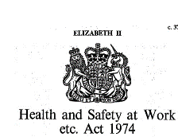
The law says
………………………………………………………………………………………………………………………………………………………………………………………………………………………………………..……………………………………………………….

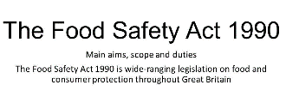

What could be the damage to the reputation of an establishment?.
………………………………………………………………………………………………………………………………………………………………………………………………………………………………………………………………………………………………………………………………………..

Assessing risk

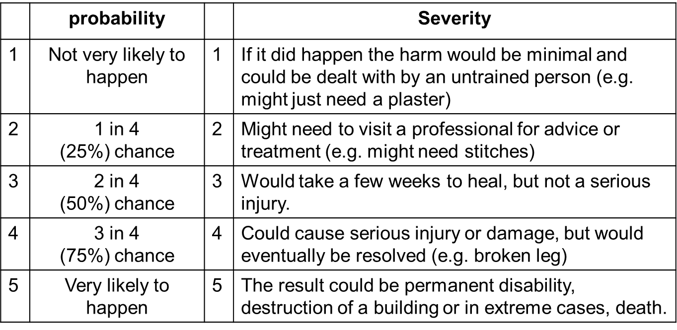

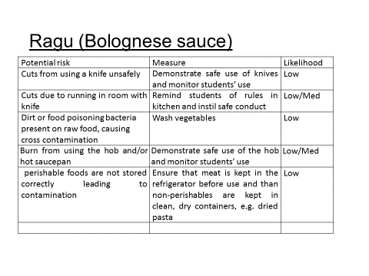
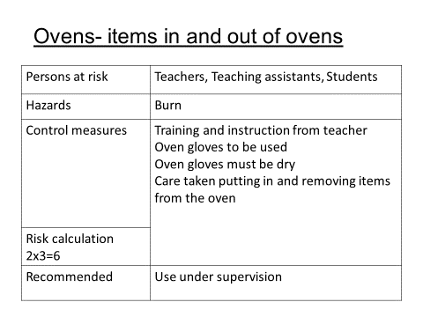
Potential risk | Measure | Likelihood

Potential risk | Measure | Likelihood

Risk and security
Workers can be at risk from security hazards in the same way as they are from safety hazards . Security risks include:
……………………………………………………………………………………………………………………………………………………………………………………………………………………………………………………………………………………………………………………………………………………………………………………………………………………….……………………………..






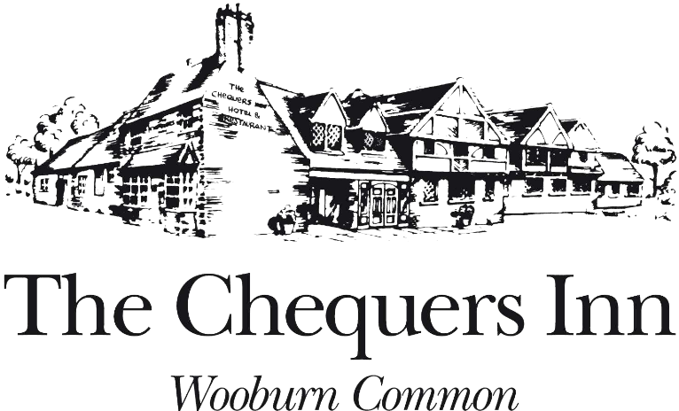
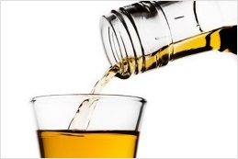
Risk factors

Discuss the ways an establishment can reduce safety and security risks for their staff (10)
…………………………………………………………………………………..
…………………………………………………………………………………..
………………………………………..…………………………………………
…………………………………..………………………………………………
………..…………………………………………………………………………
……………………………………………………………………………..……
…………………………………………………………………………………..
…………………………………………………………………………………..
…………………………………………………………………………………..
…………………………………………………………………………………..
…………………………………………………………………………………..
…………………………………………………………………………………..
…………………………………………………………………………………..
…………………………………………………………………………………..
…………………………………………………………………………………..
…………………………………………………………………………………..
…………………………………………………………………………………..
…………………………………………………………………………………..
…………………………………………………………………………………..
…………………………………………………………………………………..
…………………………………………………………………………………..
…………………………………………………………………………………..
…………………………………………………………………………………..
…………………………………………………………………………………..
…………………………………………………………………………………..
…………………………………………………………………………………...

AC 3.3 Personal safety recommendations


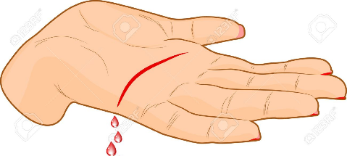

Preventing cuts
1
2
3
4
5
6
7
8
9
10

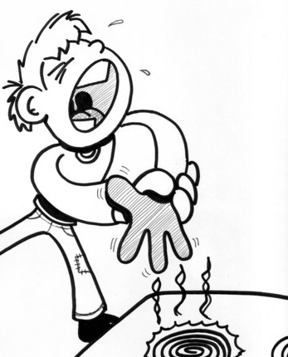

Preventing burns
1
2
3
4
5
6
7
8
9
10

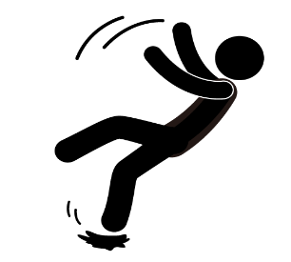

Preventing strains, slips and falls
1
2
3
4
5
6
7
8
9
10

AC 3.3 customer safety

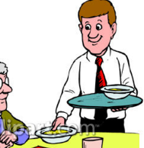
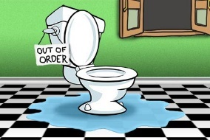

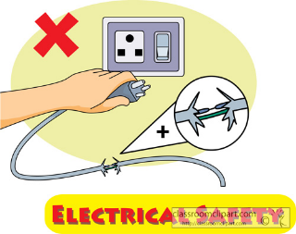
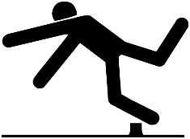
What should the waiter warn the customer?
How should customers be informed of this?
What sign should be used?
What action should be taken?
What could this sign warn the customer?

AC 3.3 Fire safety
Discovery of a fire

What action would you take?
A persons clothes catch fire
A pan of hot fat catches fire
An electrical appliance catches fire

fire prevention measures

